Field Encryption
Abstract
This document provides information on using encrypted fields within the file master system.
Table of Contents
1 Introduction 2
1.1 Purpose 2
1.2 Scope 2
1.3 Definitions, Acronyms, and Abbreviations 2
1.4 References 2
2 Basic Instructions 3
3 How to flag a field as encrypted in the File Master Program 3
4 Basics About SQL Encryption Functions 4
5 How to Use the Encryption Key 4
6 How to Change an existing field to be encrypted 5
7 CCSID in RPG Programs 5
8 Revision History 6

Introduction
This document provides information on using encrypted fields within the file master system.

Purpose
This document in intended to assist developers with using encrypted fields in the file master system.

Scope
This document only covers the specifics of using encrypted fields in the file master system. It does not cover the use of the file master system.

Definitions, Acronyms, and Abbreviations
- File Master System – A system used the generate tables in the APLLIB system. This system uses a dictionary system that standardizes all aspects of the database.

References
Additional information can be found on the file master system in the APLLIB documentation folder. It can be found in the GitHub repository at https://github.com/ttognazzini/APLLIB.

Basic Instructions
- Flag a new field as Encrypted in the File Master System and update the file
- In program that access the field, setup the encryption password
- When insert or updating a record, use the encryption function
- When selecting the field use the decryption function

How to flag a field as encrypted in the File Master Program
The file master system has had a field level option added to flag a field as encrypted. This must be done to fields that will include encrypted data. This does not do the encryption. It is just a Yes or No field that exists on the field screen. It defaults to No.
The field must be flagged as encrypted because it needs to be larger to store the encrypted data and it must have the special SQL value of “for bit data” added to the field definition.
Only CHAR and VARCHAR fields can be flagged as encrypted. Decimal data is already packed and packed fields cannot be encrypted. If a numeric field needs to be encrypted, it must be stored in a character field.
The flag is on this screen:
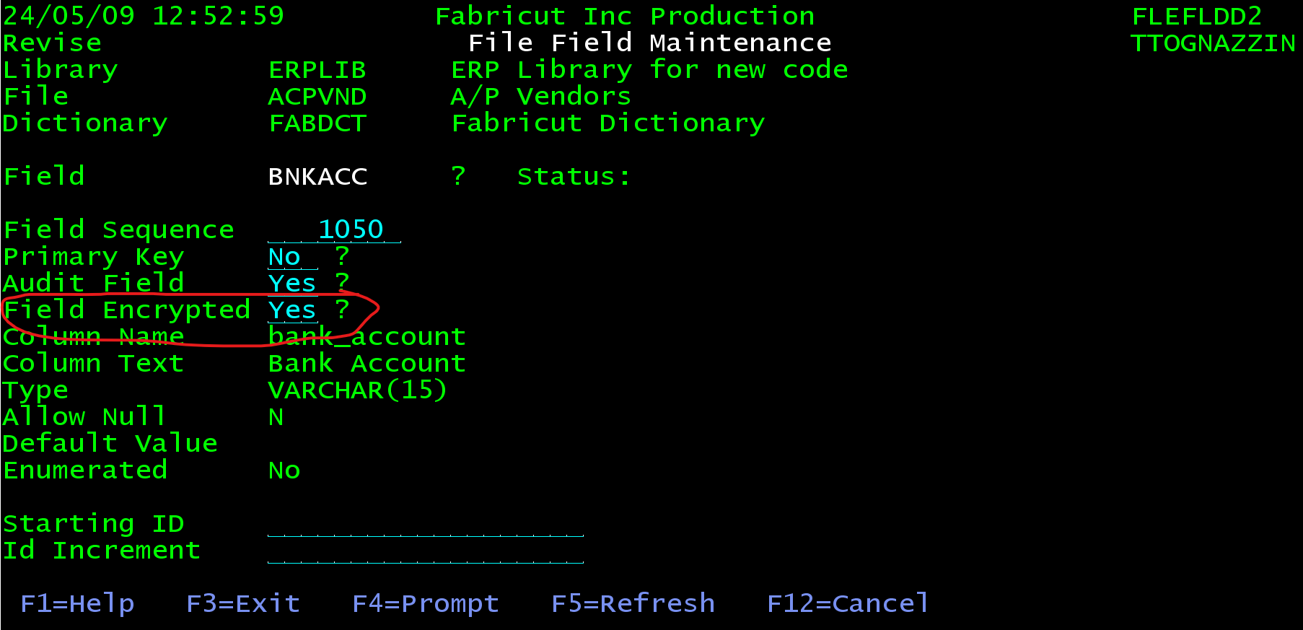

Basics About SQL Encryption Functions
SQL has several functions to encrypt data, but this system will just use the AES functions. This was the most modern algorithm available at the time this was written.
An encryption key is needed to encrypt and decrypt the data. The encryption key should be stored in a common place in the system. It is best to use a long encryption key.
The function to encrypt data using the AES standard is encrypt_aes. Only the first parameter will be used. The first parameter is just the data to be encrypted.
Update field example:
Exec SQL Update ACPVND set vndTin = encrypt_aes(:vndTin) Where acpVndIdn = :acpVndIdn;
Insert Example:
Exec SQL Insert into ACPVND
(“a bunch of fields…”,vndTin,”somemore fields…”)
Values(“a bunch of RPG fields…”,encrypt_aes(:vndTin),”some more fields…”);
The function to convert encrypted data back to regular data is decrypt_bit. The following is an example or reading the encrypted vendor TIN number from the vendor file using this function.
Exec SQL Select decrypt_bit (vndTin) into :vndTin From ACPVDN Where acpVndIdn = :acpVndIdn;
All this does is use the decryption function to populate the RPG field vndTin with the unencrypted value.

How to Use the Encryption Key
We will be using the SQL function Set Encryption Password to set the encryption key for the program. This is considered to be more secure then including the key in the same SQL statement that uses the decryption function.
The encryption key must be retrieved into an RPG variable before it can be set for the program.
Define the password variable like this:
Dcl-S password varchar(127);
Use some standard code to pull in the encryption key. The following code is an example of pulling the encryption key from a file called COMMON and setting it for the program. Modify this to pull the key form where ever it is stored.
// set password from the common file
Exec SQL Select substr(com,1,127) into :password from COMMON Where RRN(COMMON) = 997;
Exec SQL Set Encryption Password = :password;

How to Change an existing field to be encrypted
There is no automated way to do this. The following is an example of how it was done in the ACPVND file.
The vndTin field in the ACPVND file was original un-encrypted. These were the steps used to encrypt the existing date. It uses the copy the entire file method.
Flag the field in the file master as encrypted and update the file, using the F16 option from the file maintenance. This just increases the field size and allows the file to contain bit data. The data is still unencrypted in the table.
Create a little RPG program to update the data in the vndTin column to be encrypted. The following is that program:
**Free
// Encrypt the vndTin field in ACPVND

Exec SQL Set Option Commit = *none, UsrPrf = *owner, DatFmt = *ISO, DynUsrPrf = *owner, CloSQLCsr = *endmod;

Dcl-S password varchar(127);

// set password from the common file
Exec SQL Select substr(com,1,127) into :password from COMMON Where RRN(COMMON) = 997;
Exec SQL Set Encryption Password = :password;

// Encrypt the data
Exec SQL update ACPVND Set vndTin = encrypt_aes(vndTin);

Return;

CCSID in RPG Programs
The encryption stuff does not work if the job’s CCSID is 65535. That is the default for most of our users. The solution is to change the default in any program that uses encrypted fields. This can be done using the CTL-OPT CCSID(*char:37). Just put this in the CLT-OPT or H spec section of your program and it will override what the job is set without affecting other programs that could be using the job’s CCSID.

Revision History
Date | Document  Version | Description | Owner | Reason for Change
2026-06-07 | V1.0 | Initial draft | Tim Tognazzini

